**Practical: Spring Application**

The Spring Boot application is done basically for the CRUD operations. Here I have used Eclipse as the IDE, MySQL as the Database, and Postman to view the URL’s.

1. I have created a dummy data inside my HeidiSQL to view. Here it is

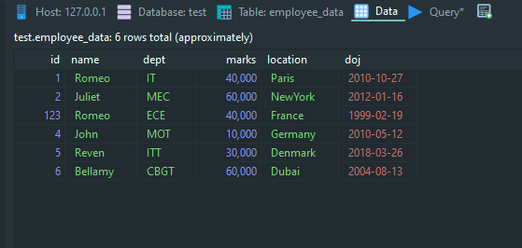

1. Here performing the GET method to fetch all the data.

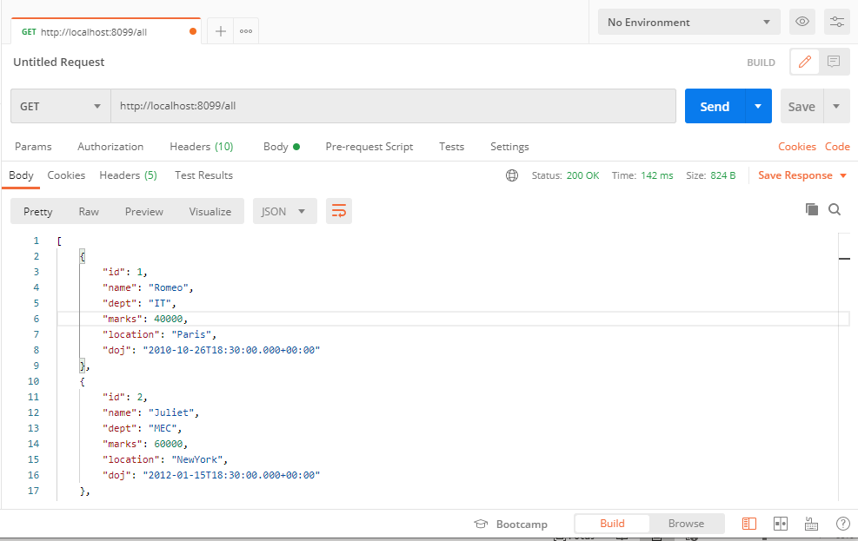

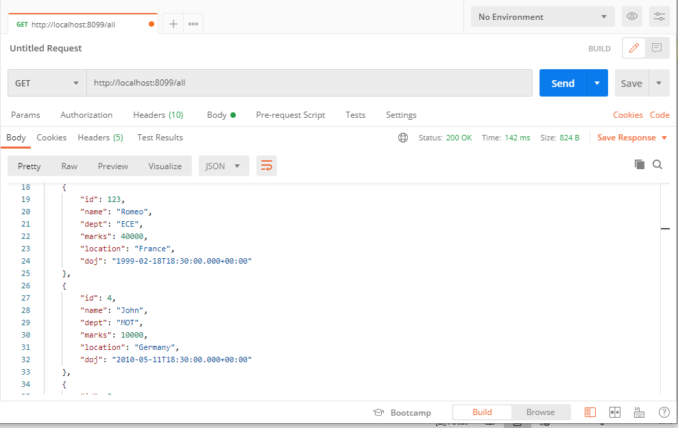

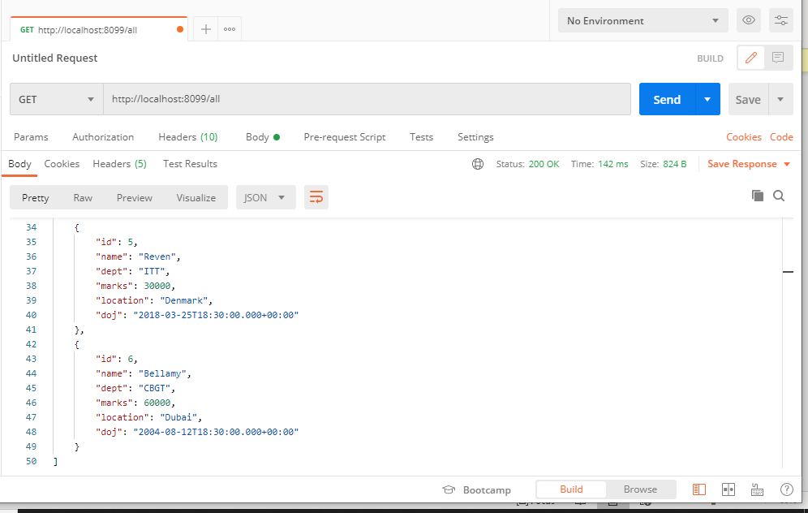

GET Methods Screenshots.

1. Now the below snippet is about adding the data to the database. The first snippet is the original data without being added.

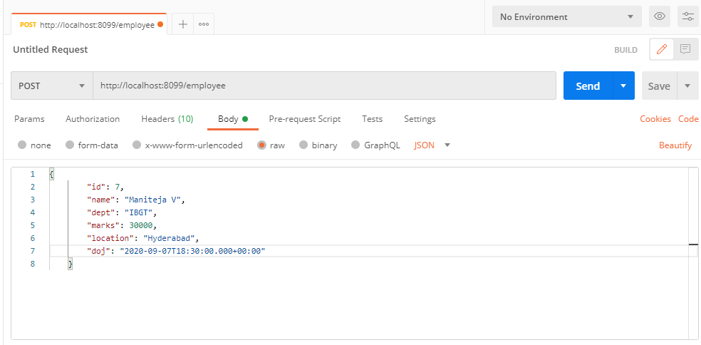

This particular data shall be added to the database.

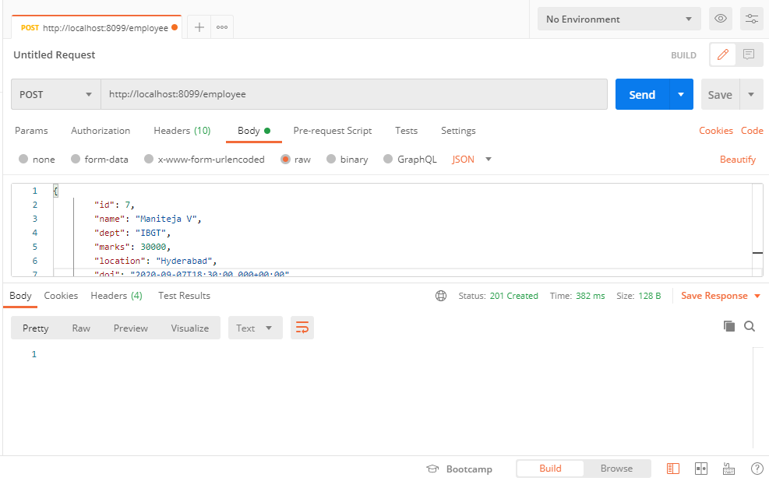

The Status code has also been changes to 201 Created

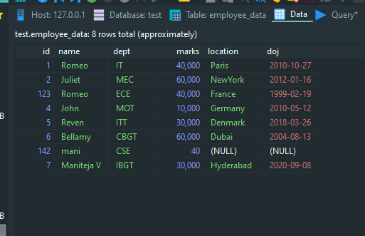

The DB is also populated with the data

1. Now the below snippet shows the Update operation for the user id 142 changing his name location ad doj.

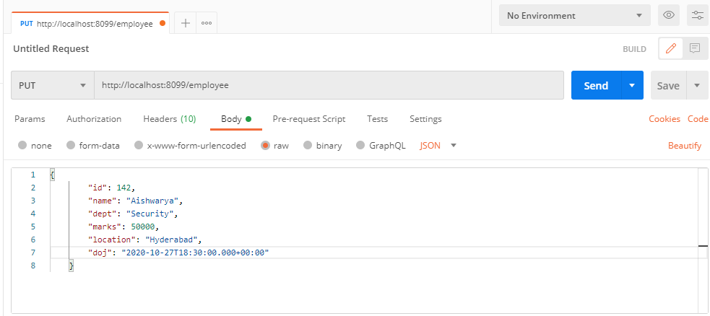

This data shall be added i.e. modified

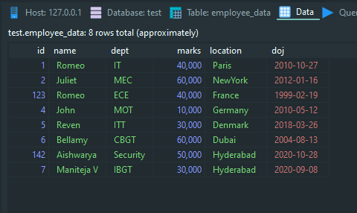

The data has been modified.

1. Now the last operation to delete. The 123 id data shall be deleted.

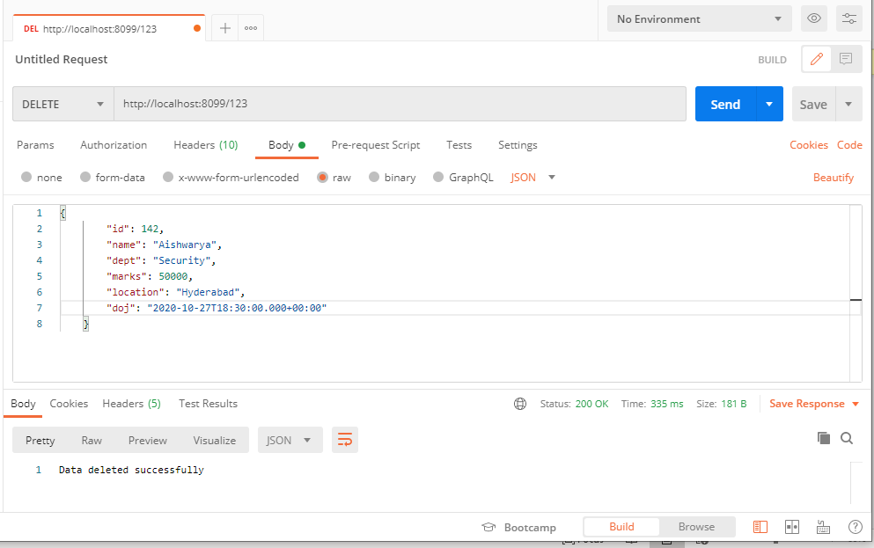

The data with the id 123 has been deleted.

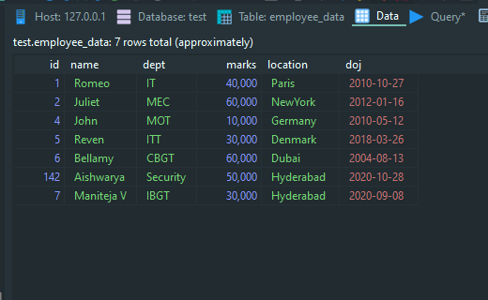

Final Database table.

Thank You